**Implementing CRM For Result Tracking Of A Candidate With Internal Marks - (ADMIN):**

**INTRODUCTION:**

The project aim is to provide real-time knowledge for all the students who have basic knowledge of Salesforce and Looking for a real-time project. This project will also help to those professionals who are in cross-technology and wanted to switch to Salesforce with the help of this project they will gain knowledge and can include into their resume as well.

What you'll learn

Real Time Salesforce Project  
Object & Relationship in Salesforce

### Create Salesforce Org

Are you new to Salesforce? Not sure exactly what it is, or how to use it? Don’t know where you should start on your learning journey? If you’ve answered yes to any of these questions, then you’re in the right place. This module is for you.

Welcome to Salesforce! Salesforce is game-changing technology, with a host of productivity- boosting features, that will help you sell smarter and faster. As you work toward your badge for  
?” this module, we’ll take you through these features and answer the question, “What is Salesforce, anyway.

## **What Is Salesforce?**

Salesforce is your customer success platform, designed to help you sell, service, market, analyze, and connect with your customers.

Salesforce has everything you need to run your business from anywhere. Using standard products and features, you can manage relationships with prospects and customers, collaborate and engage with employees and partners, and store your data securely in the cloud.

So what does that really mean? Well, before Salesforce, your contacts, emails, follow-up tasks, and prospective deals might have been organized something like

Creating a developer org in salesforce.

Go to developers.salesforce.com/Signup

1. Click on sign up.
2. On the sign-up form, enter the following details:
   1. First name & Last name
   2. Email
   3. Role: Developer
   4. Company: College Name
   5. County: India
   6. Postal Code: pin code
   7. Username: should be a combination of your name and company

This need not be an actual email id, you can give anything in the format: [username@organization.com](mailto:username@organization.com)

Click on sign up after filling these.

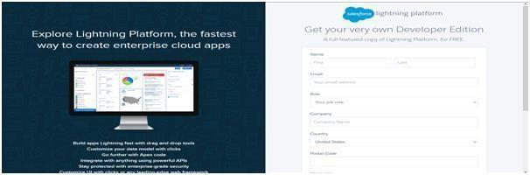

**Account Activation:**

Go to the inbox of the email that you used while signing up. Click on the verify account to activate your account. The email may take 5-10mins, as

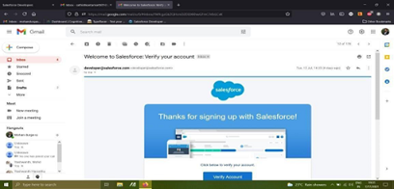

Login to Your Salesforce Account

1. Go to salesforce.com and click on login.

2. Enter the username and password that you just created.

3. After login this is the home page which you will see.

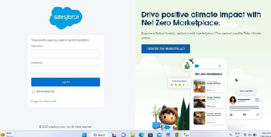

*Salesforce Login*

Login to Your Salesforce Account

1. Go to salesforce.com and click on login.

2. Enter the username and password that you just created.

3. After login this is the home page which you will see.

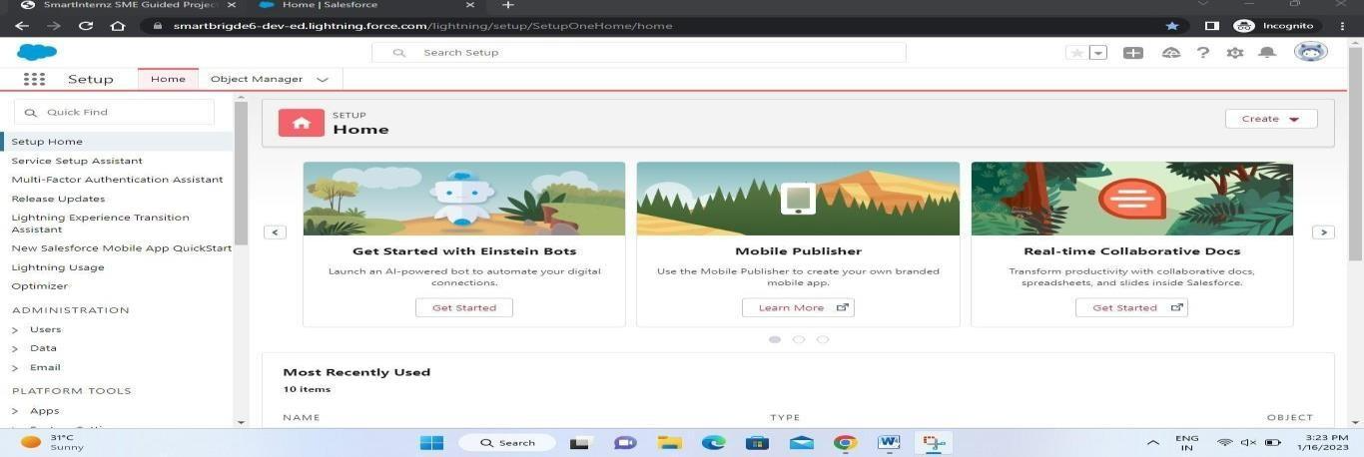

Salesforce Login htttps://login.salesforce.com

Object

.Salesforce objects are of two types:

Salesforce objects are database tables that permit you to store data that is specific to an organization

1. Standard Objects: Standard objects are the kind of objects that are provided by salesforce.com such as users, contracts, reports, dashboards, etc.

2. Custom Objects: Custom objects are those objects that are created by users. They supply information that is unique and essential to their organization. They are the heart ofany application and provide a structure for sharing data.

**Creation Of Semester Object For Candidate Internal Result Card**

1. Click on the gear icon and then select Setup.

3. After the above steps, have a look on the extreme right you will find a Create Dropdownclick on that and select Custom Object.

4. On the 2. Click on the object manager tab just beside the home tab.

Custom Object Definition page, create the object as follows:

5. Label: Semester

6. Plural Label: Semesters

7. Record Name: Semester Name

8. Check the Allow Reports

9. Check the Allow Search

10.Click Save.

In the same way create **4**more objects as **Candidate**, **Course Details**, **Lecturer Details** and **Internal results**.

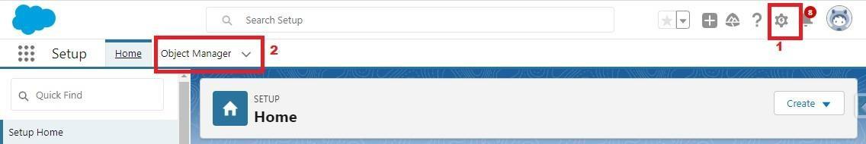

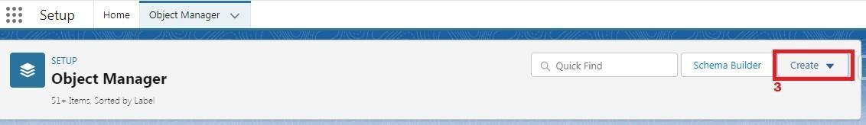

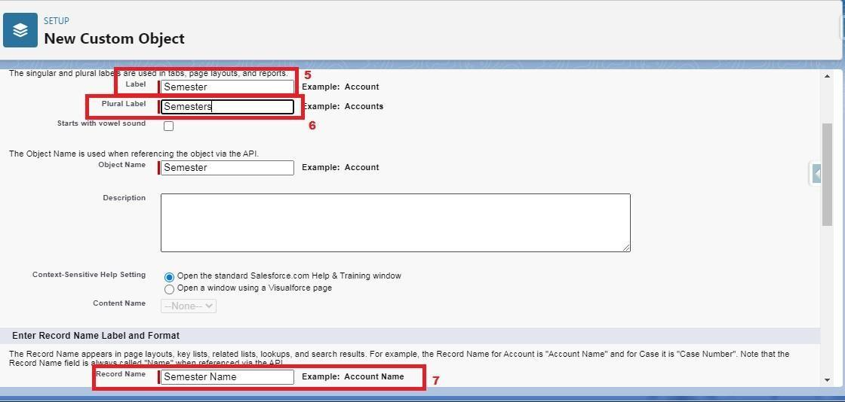  
  
  
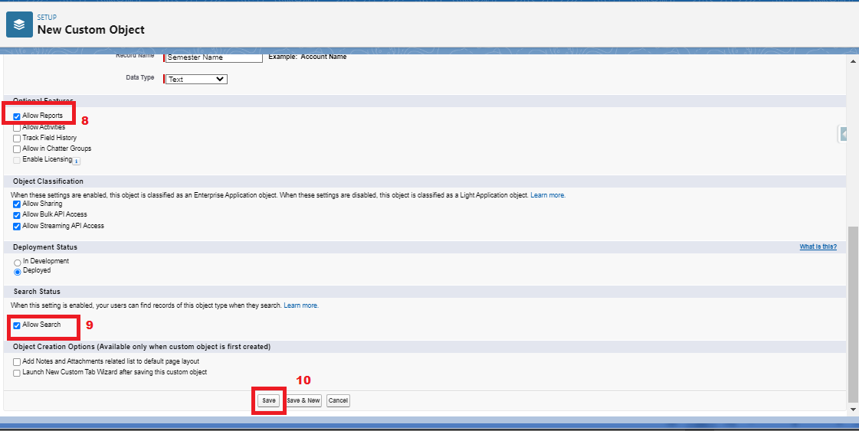

**Creation Of Semester Object For Candidate Internal Result Card**

1. Click on the gear icon and then select Setup.

2. Click on the object manager tab just beside the home tab.

3. After the above steps, have a look on the extreme right you will find a Create Dropdownclick on that and select Custom Object.

4. On the Custom Object Definition page, create the object as follows:

5. Label: Semester

6. Plural Label: Semesters

7. Record Name: Semester Name

8. Check the Allow Reports

9. Check the Allow Search

10.Click Save.

In the same way create **4**more objects as **Candidate**, **Course Details**, **Lecturer Details** and **Internal results**.





  
  
  


**What Is A Tab?**

Tabs in Salesforce help users view the information at a glance. It displays the data of objects and otherweb content in the application.

There are mainly 4 types of tabs:

(A) Standard Object Tabs: Standard object tabs display data related to standard objects

(B) Custom Object Tabs: Custom object tabs displays data related to custom objects.

(C) Web Tabs: Web Tabs display any external Web-based application or Web page in a Salesforce tabs.

(D) Visualforce Tabs: Visualforce Tabs display data from a Visualforce Page.

**Creation Of Semester Tab For Candidate Internal Result Card**

Now create a custom tab. Click the Home tab.

1. Enter Tabs in Quick Find and select Tabs.

2. Under Custom Object Tabs, click New.

3. For Object, select Semester.

4. For Tab Style, select any icon.

5. Leave all defaults as is. Click Next, Next, and Save

6. In the same way create Tabs for all Custom Objects -Candidate, Course Details, Lecturer Details, Internal results .

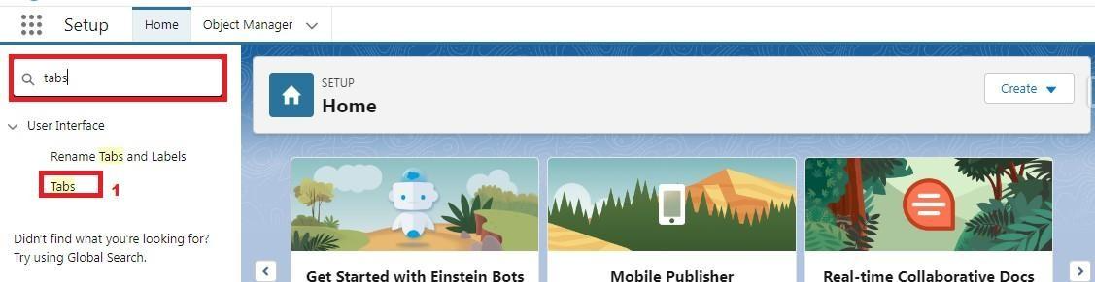

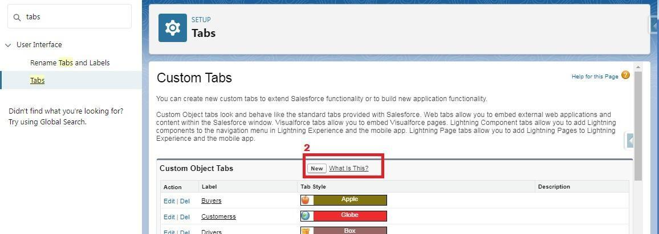

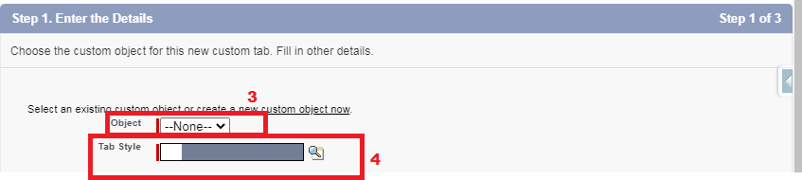

**Lightning App**

Apps in Salesforce are a group of tabs that help the application function by working together as aunit. It has a name, a logo, and a particular set of tabs. The simplest app usually has just two tabs. There are two types of app –

**1. Standard App**: Standard apps come with every occurrence of Salesforce as default. Many features like Sales, Marketing, Community, call center, content, Salesforce chatter, App Launcher, etc are present in it.

**Note:** The description, Logo, and Label of standard app cannot be altered.

**2. Custom Apps:** Custom apps are created according to need of user. Custom Apps are made by using standard and custom tabs together.

**Note:** Logos for Custom Apps can be changed.

**Create The Candidate Internal Result Card App**

1. From Setup, enter App Manager in the Quick Find and select App Manager.

2. Click New Lightning App.

3. Enter **Candidate Internal Result Card** as the App Name, then click next

4. Under App Options, leave the default selections and click next.

5. Under Utility Items, leave as is and click Next.

6. From Available Items, select **Semester**, **Candidate**, **Course Details**, **Lecturer Details**, **Internalresults**, **Reports**, and **Dashboards** and move them to Selected Items.

7. Click Next.

From Available Profiles, select System Administrator and move it to Selected Profiles. Click Save & Finish.

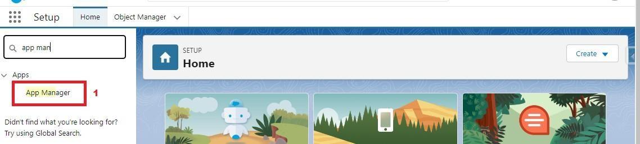

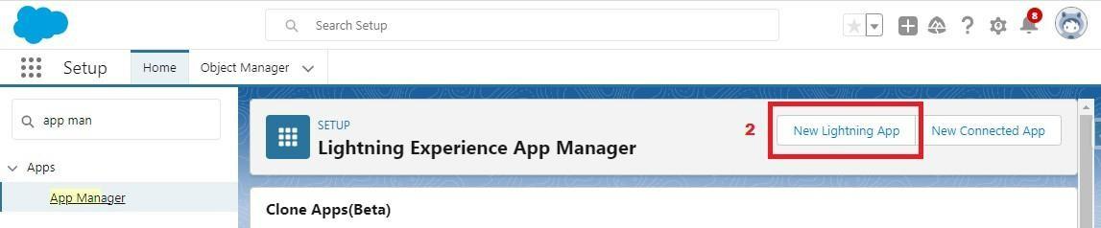

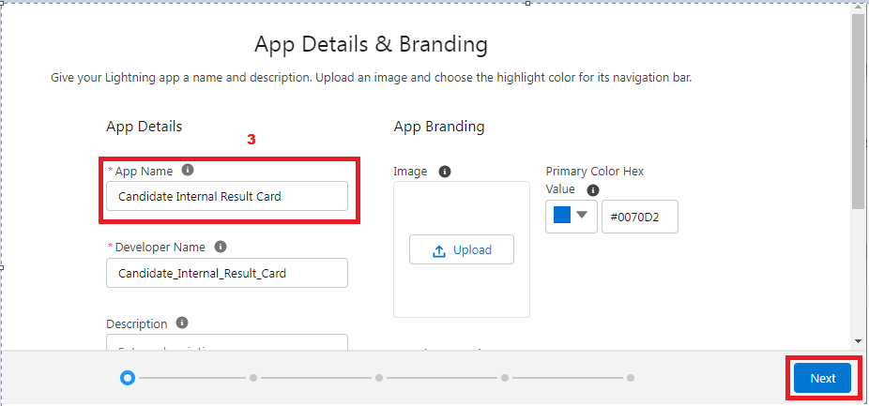  
  
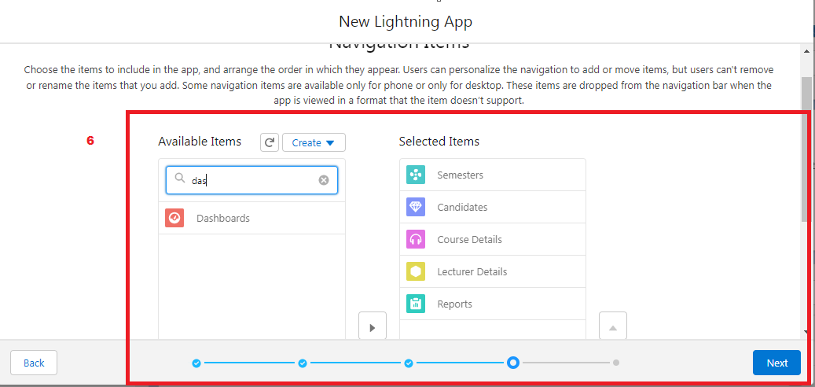  
  
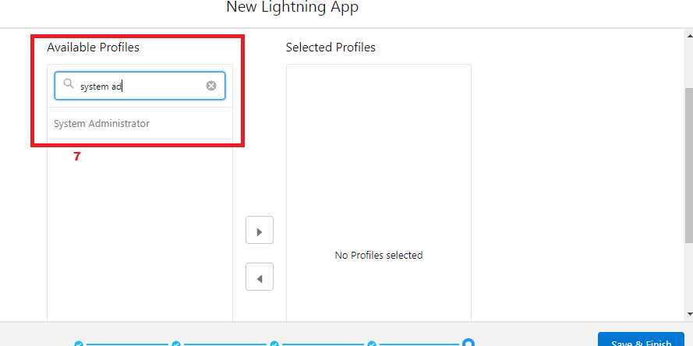

  
  


**Fields And Relationship**

Fields - Fields store data values that are required for a particular object in a record.

An object relationship in Salesforce is a two-way association between two objects. Relationships are created by creating custom relationship fields on an object. This is done so thatwhen users view records, they can also see and access related data.

|  |  |  |
| --- | --- | --- |
| Object Name | Field Name | Data type |
| Semester | Semester Name | Text(Standard field) |
|  | Course | Lookup(Course Details) |
| Candidate | Candidate Name | Text(Standard field) |
|  | Candidate Roll  Number | Auto Number |
|  | Semester Name | Lookup(Semester) |
| Lecturer Details | Lecturer Name | Text(Standard field) |
|  | Lecturer Role | Text |
|  | Course | Lookup(Course) |
| Course Details | Course Name | Text(Standard field) |
|  | Duration (Years) | Number |

|  |  |  |
| --- | --- | --- |
| Internal results | Candidate | Lookup (candidate) |
|  | Candidate Roll Number | Formula |
|  | Course | Lookup(Course) |
|  | Marks | Number |

**Creation Of Text Field On "Lecturer Details" & Look Up Field For The “Candidate” Object**

1.Click the gear icon and select Setup. This launches Setup in a new tab.

2. Click the Object Manager tab next to Home.

3. Select Lecturer Details

4. Select Fields & Relationships from the left navigation

5. Click New

6. Select the Text as the Data Type, click next.

7. For Field Label, enter Lecturer Role

8. Enter Length 40

9. Click Next, Next, then Save & New.

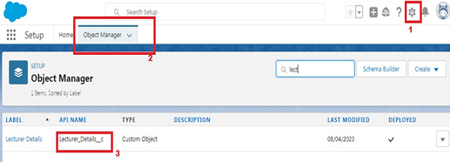  
  
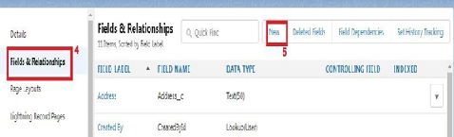

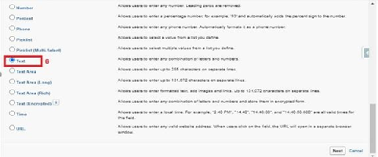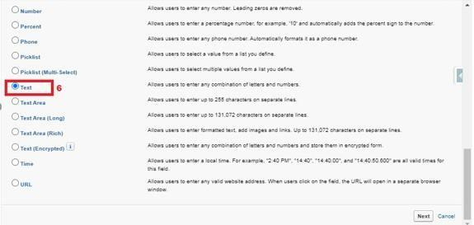

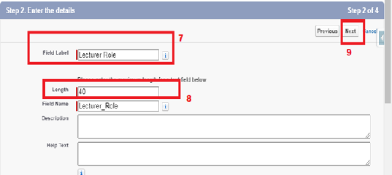

Now Let’s create a Lookup field on candidate object

1. Click the gear icon and select Setup. This launches Setup in a new tab.

2. Click the Object Manager tab next to Home.

3. Select candidate.

4. Select Fields & Relationships from the left navigation

5. Click New

6. Select the lookup as the Data Type, then click Next.

7. In related select Semester

8. For Field Label Semester Name, enter.

9. Click Next, Next, then Save & New.





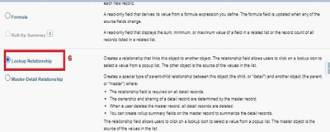

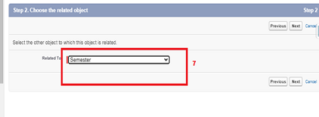

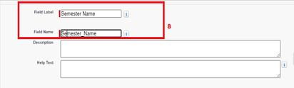

Note- Similarly create all lookup fields on their respective objects.

**Creation Of Auto Number Field On Candidate Object, Number Field On Course Details Object & Formula Field Course Details Object**

value in Years

* 1. Click Next, Next, then Save & New.





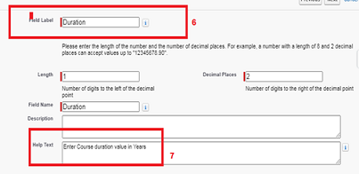

Now Let’s create a Formula field on Internal Results object

1. Click the gear icon and select Setup. This launches Setup in a new tab.

2. Click the Object Manager tab next to Home.

3. Select Internal results.

4. Select Fields & Relationships from the left navigation.

5. Click New

6. Select the Formula as the Data Type, then click Next.

7. Give field label Candidate Roll Number

8. Select formula return type text, Click Next

9. Click Insert Field

10.Create and insert formula Candidate r.Candidate_Roll_Number   c, and then click Insert.

11.Click Next, Next, then Save.





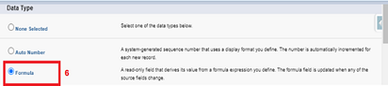

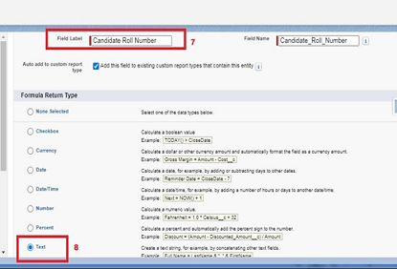

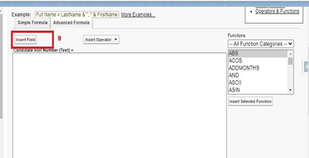

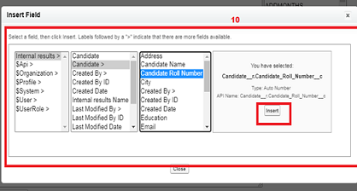

Now Let’s create an auto number field on Candidate object

1. Click the gear icon and select Setup. This launches Setup in a new tab.

2. Click the Object Manager tab next to Home.

3. Select Candidate.

4. Select Fields & Relationships from the left navigation

5. Click New

6. Select the Auto Number as the Data Type, then click Next.

7. For Field Label Candidate enter Roll Number.

8. Give a display format

9. Click Next, Next, then Save & New.





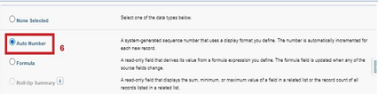

**Creation Of Auto Number Field On Candidate Object, Number Field On Course Details Object & Formula Field Course Details Object**

Let’s create a Number field on Course Details object

1. Click the gear icon and select Setup. This launches Setup in a new tab.

2. Click the Object Manager tab next to Home.

3. Select Course Detail.

4. Select Fields & Relationships from the left navigation

4. Click New & select number field, click Next

6. For Field Label Duration, enter.

7. Give Help Text- Enter Course duration value in Years

8. Click Next, Next, then Save & New.







Now Let’s create a Formula field on Internal Results object

1. Click the gear icon and select Setup. This launches Setup in a new tab.

2. Click the Object Manager tab next to Home.

3. Select Internal results.

4. Select Fields & Relationships from the left navigation.

5. Click New

6. Select the Formula as the Data Type, then click Next.

7. Give field label Candidate Roll Number

8. Select formula return type text, Click Next

9. Click Insert Field

10.Create and insert formula Candidate r.Candidate_Roll_Number   c, and then click Insert.

11.Click Next, Next, then Save.













Now Let’s create an auto number field on Candidate object

1. Click the gear icon and select Setup. This launches Setup in a new tab.

2. Click the Object Manager tab next to Home.

3. Select Candidate.

4. Select Fields & Relationships from the left navigation

5. Click New

6. Select the Auto Number as the Data Type, then click Next.

7. For Field Label Candidate enter Roll Number.

8. Give a display format

9. Click Next, Next, then Save & New.







**Users**

A user is anyone who logs in to Salesforce. Users are employees atyour company, such as sales reps, managers, and IT specialists, whoneed access to the company's records. Every user in Salesforce has auser account.

**Creating A User**

1. From Setup, in the Quick Find box, enter Users.

2. Select Users.

3. Click New User.

4. Enter the First Name, Class, Last Name, Teacher and (Your) email address anda unique username in the form of an email address. By default, the username is the same as the email address.

5. Select a User License as salesforce.

NOTE- As Salesforce license can only be used by 2 Users at a time in Dev Org, so If you don’t find salesforce license then deactivate a user who has salesforce license Or change the license type from Salesforce to any other.

6. Select a profile as Standard user.

7. Check Generate new password and notify the user immediately to have the user’s login name and a temporary password emailed to your email.  
  
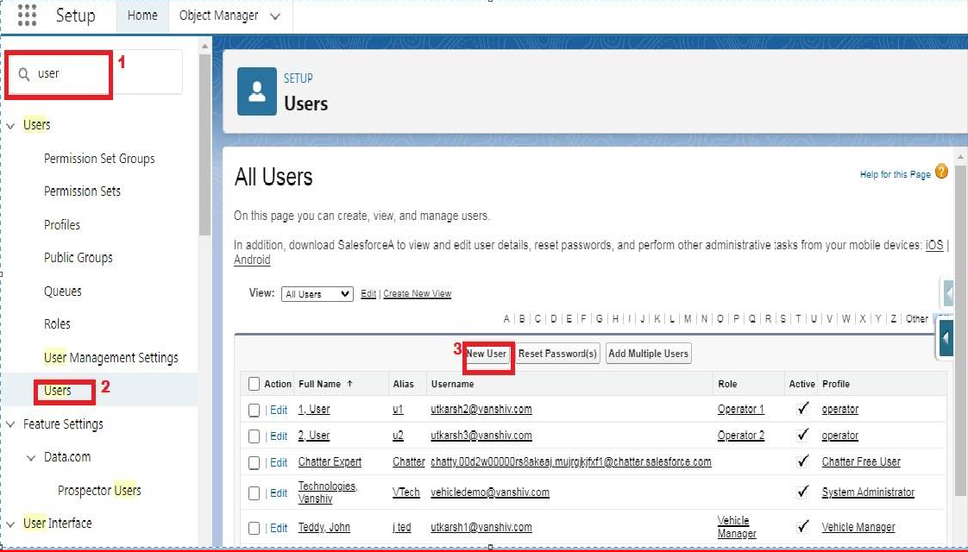

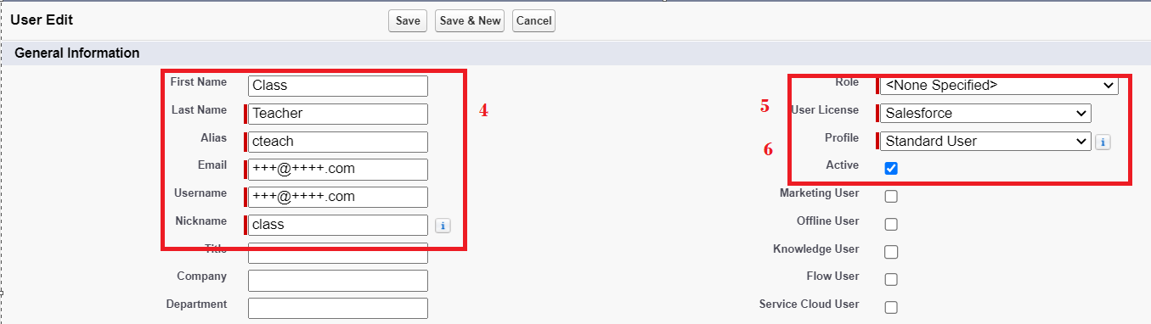

**User Adoption**

Salesforce user adoption is the simple act of enabling a user to use SFDC's full CRM capabilities by creating strategies around onboarding, training, and continued development – all to drive overall digital adoption.

**Create Record (Course Details):**

Create Records on Course Details Objects

1. Click on App Launcher on left side of screen.

2. Search Candidate Internal Result Card App & click on it.

3. Click on Course Details tab.

4. Click new button

5. Fill all Course Details record details.

6. Click on Save Button.

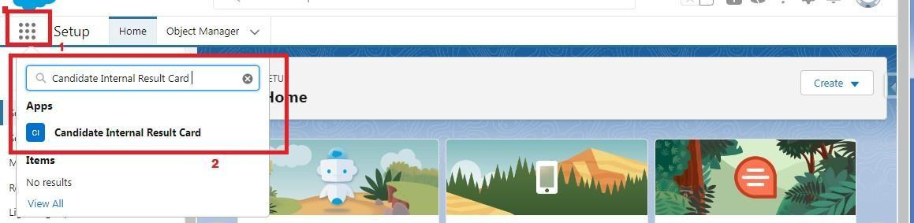

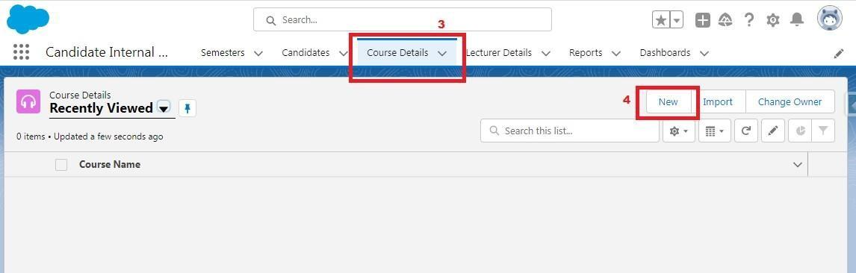

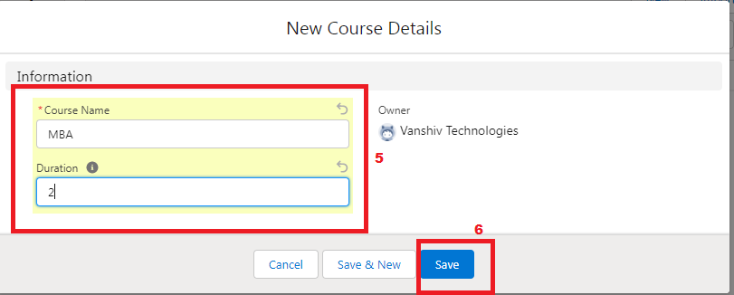

**Delete Record (Course Details):**

Deleting Records of Course Details Object

1. Click on App Launcher on left side of screen.

2. Search Candidate Internal Result Card & click on it.

3. Click on Course details Tab.

4. Click on Arrow at right hand side on that Particular record.

5. Click delete and delete again.



### View Record (Course Details):

Viewing the Records of Course Detail Object

1. Click on App Launcher on left side of screen.

2. Search Candidate Internal Result Card & click on it.

3. Click on Course details Tab.

4. Click on any record name. you can see the details of the Driver



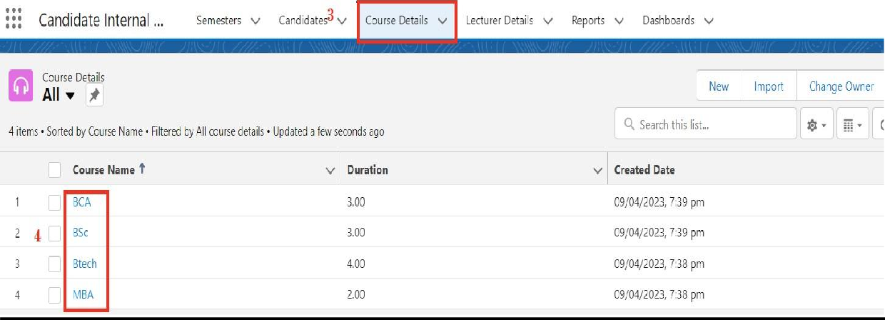

* + What Are Reports?
    - Create Report
    - View Report
  + Dashboards

**Delete Record (Course Details):**

Deleting Records of Course Details Object

1. Click on App Launcher on left side of screen.

2. Searc h Candidate Internal Result Card & click on it.

3. Click on Course details Tab.

4. Click on Arrow at right hand side on that Particular record.

5. Click delete and delete again.



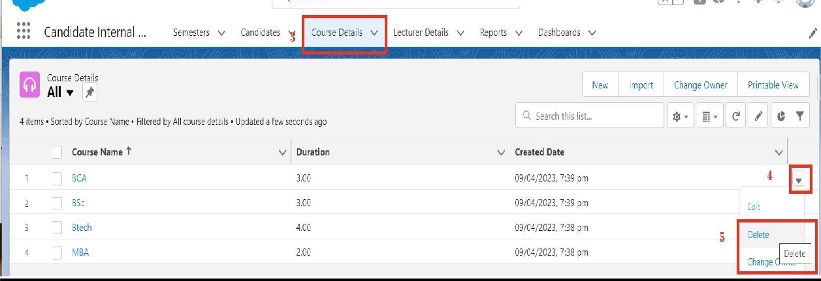

**What Are Reports?**

Reports in Salesforce is a list of records that meet a particular criterion which gives an answerto a particular question. These records are displayed as a table that can be filtered or grouped based on any field.

There are 4 types of report formats in Salesforce:

**Tabular Reports:**

This is the most basic report format. It just displays the row of records in a table with a grand total. While easy to set up they can’t be used to create groups of data or charts and also cannot beused in Dashboards. They are mainly used to generate a simple list or a list with a grand total.

**Summary Reports:**

It is the most commonly used type of report. It allows grouping of rows of data, view subtotal,and create charts.

**Matrix Report:**

It is the most complex report format. Matrix report summarizes information in a grid format. It allows records to be grouped by both columns and rows. It can also be used to generate dashboards. Charts can be added to this type of report.

**Joined Reports**:

These types of reports let us create different views of data from multiple report types. The data is joined reports are organized in blocks. Each block acts as a sub-report with its own fields, columns, sorting, and filtering. They are used to group and show data from multiple report types in different views.

**Report types**:

**Report type** determines which set of records will be available in a report. Every report is based on a particular report type. The report type is selected first when we create a report. Every reporttype has a primary object and one or more related objects. All these objects must be linked together either directly or indirectly.

A report type cannot include more than 4 objects. Once a report is created its report type cannot be changed.

There are 2 types of report types:

**Standard Report Types**: Standard Report Types are automatically included with standard objects and also with customobjects where “Allow Reports” is checked. Standard report types cannot be customized and automatically include standard and custom fields for each object within the report type. Standard report types get created when an object iscreated, also when a relationship is created.

**Note:** Standard report types always have inner joins.

**Custom Report Types**: Custom report types are reporting templates created to streamline the reporting

process. Custom Reports are created by an administrator or User with “Manage Custom Report Types” permission. Custom report types are created when standard report types cannot specify which records will be available on reports.

In custom report types we can specify objects which will be available in a particular report.

The primary object must have a relationship with other objects present in a report type either directly or indirectly.

There are 3 types of access levels of folders:

**Viewer**: With this access level, users can see the data in a report but cannot make any changes except cloning it into a new report.

**Editor**: With this access level, users can view and modify the reports it contains and can also move themto/from any other folders they have access level as Editor or Manager.

**Manager**: With this access level, users can do everything Viewers & Editors can do, plus they can alsocontrol other user’s access levels to this folder. Also, users with Manager Access levels can delete the report.

**Create Report**

1. Click App Launcher

2. Select Candidate Internal Result Card App

3. Click reports tab

4. Click New Report.

5. Click the report type as Semesters with Course Click Start report.

6. Customize your report, in group rows select - Course Name, in group column Select Duration (In this way we are making a Matrix Report).

7. Click refresh

8. Click save and run

9. Give report name – Candidate Internal Result Report

10.Click Save

NOTE: In this report you can see your all record of the object you selected for reporting (What you Selects in “Select a report type option”).



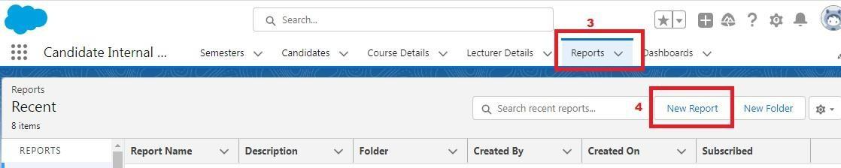

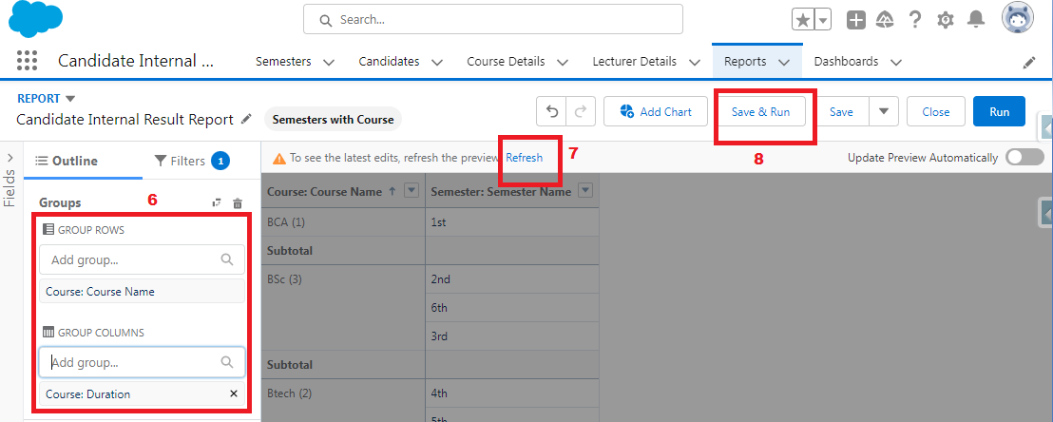  
  
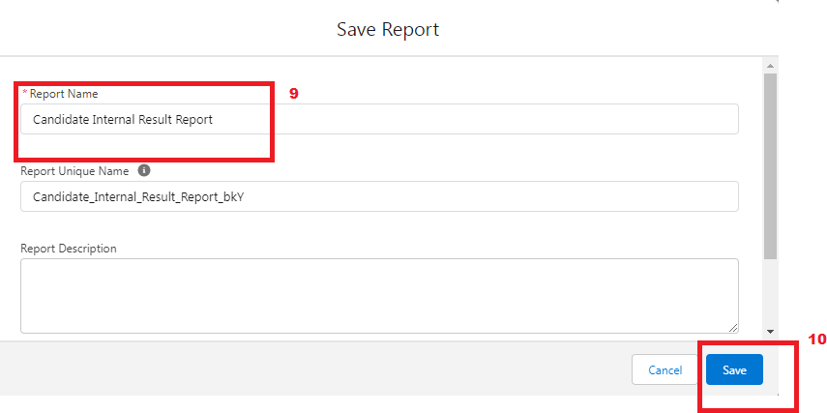

1.    On the report builder page, locate the "Fields" pane on the left-hand side.

2.    Find the field for which you want to create a bucket field and drag it to the report preview section.

3.    Click on the field in the report preview to open the field properties.

4.    In the field properties, locate the "Summarize" option and click the drop-down arrow.

5.    Select "Bucket Field" from the available options.

6.    In the bucket field settings, define the buckets based on your requirements. You can specify the bucket ranges, labels, and groupings.

7.    Click "OK" or "Apply" to save the bucket field settings.

8.    Customize the report layout and add any additional fields or filters as needed.

9.    Once you are satisfied with the report setup, click "Save" to save the report.

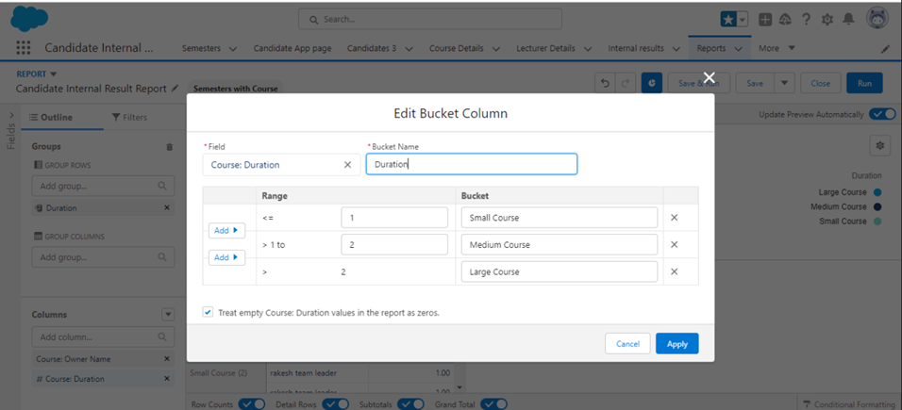

**View Report**

1. Click on App Launcher on left side of screen.

2. Search Candidate Internal Result Card App & click on it.

3. Click on Reports Tab.

4. Click on Candidate Internal Result Report and see records.



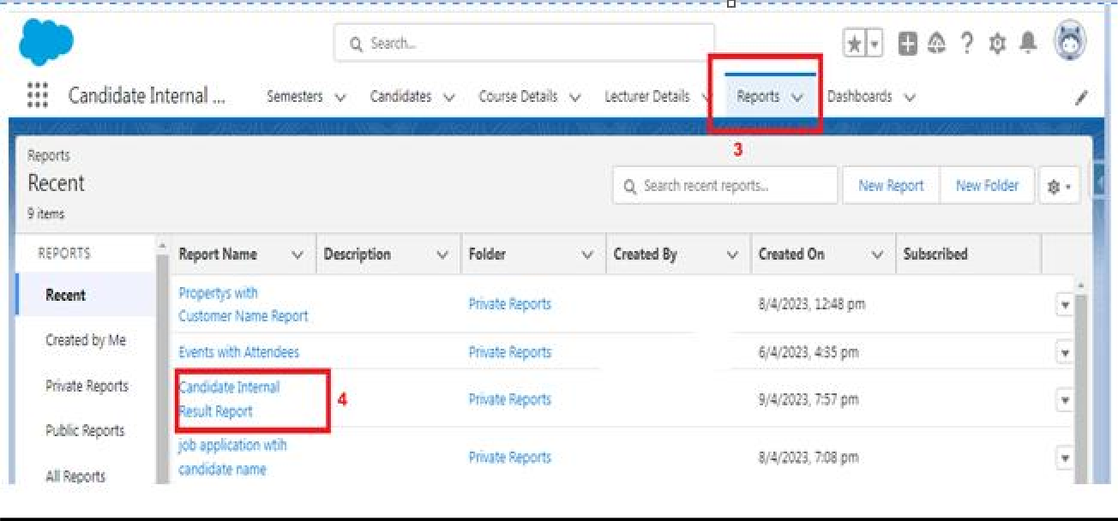

**Dashboards**

Dashboards let you curate data from reports using charts, tables,and metrics. If your colleagues need more information, then they'reable to view your dashboard's data-supplying reports. Dashboard filters make it easy for users to apply different data perspectives to asingle dashboard.

**Create Dashboard**

1. Click on Dashboards tab from the Candidate Internal Result Card application.

2. Click on new dashboard.

3. Give name- Candidate Internal Result Card

4. Click create

5.  Give your dashboard a name and click on +component

6. Select the Candidate Internal Result Report which you created.

7. For the data visualization select any of the chart, table etc. as per your choice/requirement.

8. Click add.

9. Click save.

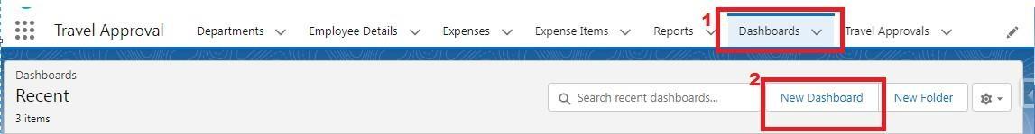

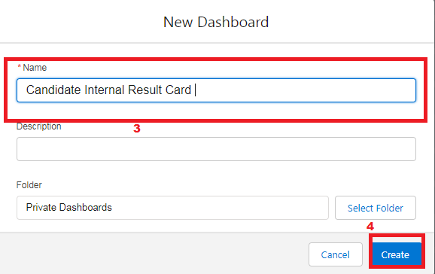

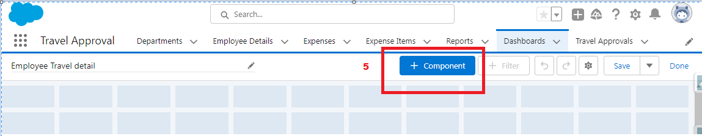  
  
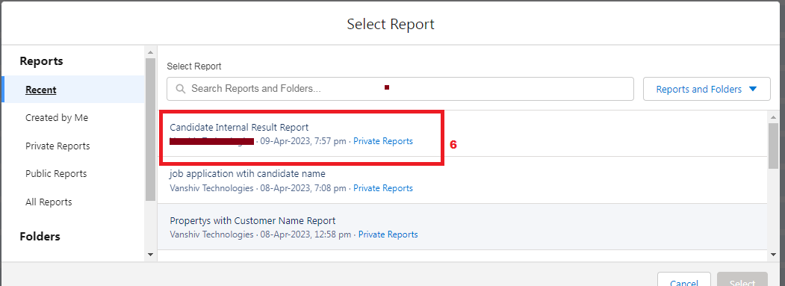

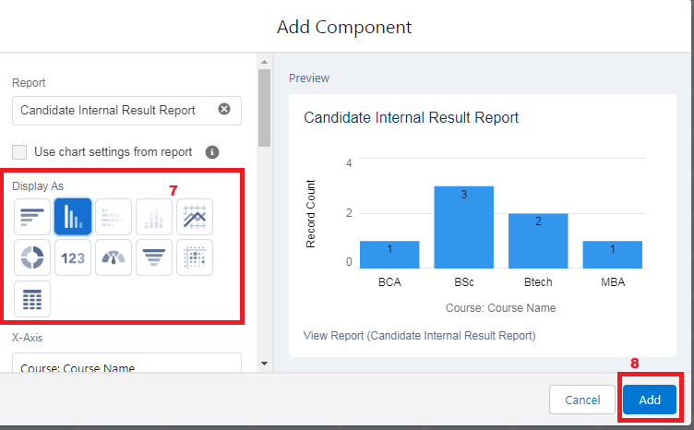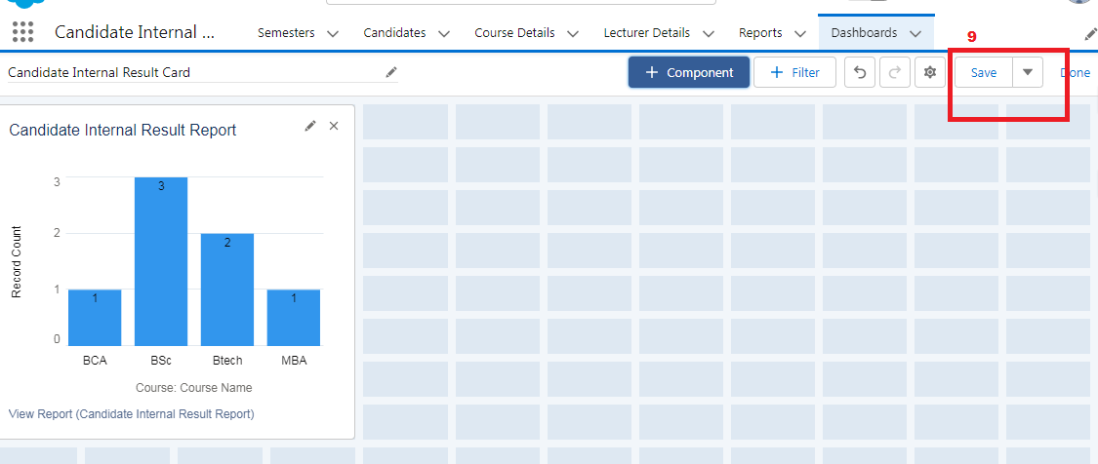

**View Dashboard**

1. Click on App Launcher on left side of screen.

2. Search Candidate Internal Result Card & click on it.

3. Click on Dashboard Tab.

4. Click on Candidate Internal Result Card see graph view of records



